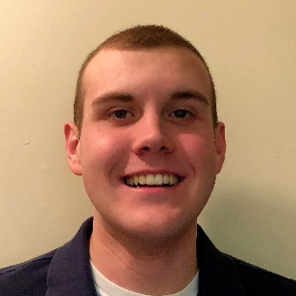
My name is Ryan Casey, and I am currently attending Binghamton University as a freshman in the class of 2022. That being said, I am set to obtain my bachelor’s degree of Psychology in 2021, attend the Binghamton University School of Pharmacy starting that same year, and graduate with a Ph.D. of Pharmacy in 2025. A fun fact about me is that I have been a violinist since I was in fourth grade, and I am continuing to play here at Binghamton through the Explorchestra club. I joined RYP in 2016 with Josh Kartzman, a friend from my high school. I was a member of RYP for two straight years before I graduated.
Since my graduation from RYP, my passion for community service has only continued to group. Binghamton University has numerous community service opportunities offered on and off campus. I am currently a member of the Student Volunteer Center (SVC), which is a community service- and volunteer-oriented club on campus. In addition to this club, I have been in contact with a coed community service-based fraternity called Alpha Phi Omega, which I plan on trying to join during my Spring semester this year. There are other services as well, but these are the two main ones that I have been involved with thus far. I am always keeping an eye out for opportunities to help the community, and I cannot wait to get even more involved than I already am, even when I return home for breaks.
As fun as the community service has been, college itself has been a blast so far! I am currently living in the Mountainview dorm community on campus in a six-person suite. Going into college, I did not know any of the guys I am living with. Now, I am extremely good friends with all of them. We have not had any problems between any of us, and I cannot wait to see how the rest of the school year with my suite mates goes. The community here at Binghamton has been amazing as well! There is always something to do and the people here are so nice! I have joined three clubs so far (Explorchestra, SVC, and Meditation Club), and I have my eyes on some others. It is very easy to get involved here on campus if you want to. Just being here makes me excited! My classes are stressful, of course, but that is to be expected when you take 18 credit hours. While balancing it all is a struggle, there is a lot of good to keep things fun. Through all this separation and business, I have still managed to maintain contact with some of my fellow graduates from RYP (Mitchell Vargas, Kate Major, and Josh Kartzman, just to name a few). On top of that, my sister (Jillian Casey) is still a member RYP carrying on my legacy. I have so much to thank RYP and the people behind it for. I can attribute so much of my success to these people and this organization. I have truly grown to feel at home here at Binghamton University, but there is no way I could ever forget my roots and the experiences that have gotten me to where I am today. Thank you RYP, and a big thank you to Katie!

